SAN DIEGO RIVERSIDE CHARTER SCHOOL
PO Box 99/504 Mission Road
Jemez Pueblo, New Mexico 87024
Phone: 575.834.7419

Minutes of the ZOOM ONLINE
GOVERNING COUNCIL MEETING
Thursday, September 9th, 2021
6:30 PM Online ZOOM Meeting

I. Call Meeting to Order
The meeting was called to order by Ms. Creel at 6:34 PM.

II. Roll Call and Quorum Verification

Members Present: Members Not Present:
Susan Bacca None.
Margie Creel
Dr. Justina Montoya
Bobbie Shendo (Arrived at 6:45 PM)
Minutes: John Rodarte
Guests:
John Rodarte, Principal
Valerie Shaw, Vice Principal
Jolene Jaramillo, Interim Business Manager
Dorell Toya-Upshaw, Administrative Assistant

Council members present were provided copies of all meeting documents prior to the meeting with the exception of financial reports as provided by Ms. Jolene Jaramillo.

III. Opening Activities
A. Approval of September 9, 2021 Agenda (Discussion/Action)
Ms. Creel called for a motion to approve the Agenda. Dr. Montoya made a motion to approve the Agenda seconded by Ms. Bacca. No further discussion transpired. The motion carried unanimously.

B. Approval of Meeting Minutes of August 12, 2021 (Discussion/Action)
Ms. Creel asked for a motion to approve the Minutes. Ms. Bacca made a motion to approve the Minutes of both the Governing Council Meeting of August 12th with the Minutes of the Special Meeting of the Governing Council held on August 19th in one motion. The motion was seconded by Dr. Montoya. No further discussion transpired. The motion carried unanimously.

C. Approval of Special Meeting Minutes of August 19, 2021 (Discussion/Action)
See Item III. B. above.

IV. Finance Committee Report
A. Interim Business Manager’s Report – Jolene Jaramillo (Discussion)
Ms. Jaramillo provided an overview of all prepared reports.

B. Approval of Cash Disbursements (Discussion/Action)
Ms. Jaramillo provided an overview of funds spent in Cash Disbursements. Dr. Montoya made a motion to approve the cash disbursements. Ms. Shendo seconded the motion. No further discussion transpired. Motion passed unanimously.

C. Approval of BARS (Discussion/Action)
Ms. Jaramillo presented 17 BARs for the approval of the Governing Council.

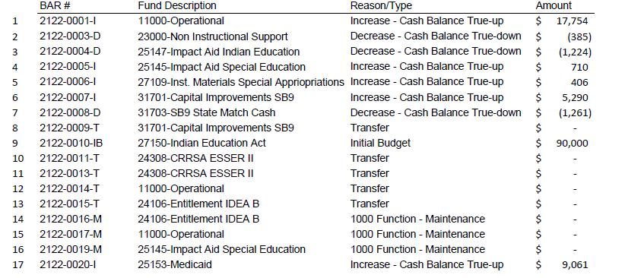

Dr. Montoya made a motion to approve all 17 BARs under one motion. The motion was seconded by Ms. Bacca. No further discussion transpired. The motion carried unanimously.

V. Principal’s Report
A. Principal’s Monthly Report – John Rodarte (Discussion)
Copies of report provided to all Governing Council members prior to meeting. Mr. Rodarte commented about the contents of the report including enrollment, student attendance, and staff vacancies. Mr. Rodarte stood for questions. No further discussion transpired. No action was taken.

VI. Public Comment
A. Public Comment
Public comments submitted by guests and captured in on ZOOM Chat. Ms. Dorell Toya-Upshaw thanked Mr. Rodarte for the flexibility and support regarding Leave during her recent hardships. Lastly, a request as made by the Governing Council to put GC Training on the next Agend.

VII. Announcements
The next meeting is scheduled for Thursday, October 14th, 2021.

VIII. Consideration for Approval to Adjourn to Closed Session Pursuant to the Open Meetings Act NMSA 1978 (§ 10-15-1 (H)(2) (Limited Personnel Matters)
A motion to move into Closed Session to discuss limited personnel matters was made by Ms. Bacca and seconded by Ms. Shendo. Motion passed unanimously. Closed Session began at 7:18 PM.

IX. Reconvene to Open Meeting
A motion to move out of Closed Session was made by Dr. Montoya and seconded by Ms. Bacca. Motion passed unanimously. Closed Session ended at 7:58 PM.

X. Statement of Closure
Governing Council asserts that only limited personnel matters were discussed during closed session in compliance with NMSA 1978 (§ 10-15-1 (H)(2) (Limited Personnel Matters).

XI. Meeting Adjournment
Ms. Creel called for a motion to adjourn the meeting. Ms. Bacca moved to adjourn the meeting. The motion was seconded Ms. Shendo. No further discussion transpired. The meeting ended at 8:00 PM.

